LAND DEGRADATION AND SOIL EROSION

A Community Service Project report

submitted in the partial fulfillment of the requirements for

the award of the degree of

Bachelor of Technology
in
Computer Science and Engineering

Submitted by

R. BALU (23761A05B5)
R. SOWJANYA (23761A05B6)
R.V. PUSHPA LATHA (23761A05B7)
S.V. RAKESH VARMA (23761A05B8)
SY. ARSHATH (23761A05B9)

Under the guidance of
M.GAYATHRI
Assistant Professor



Department of Computer Science and Engineering

LAKIREDDY BALI REDDY COLLEGE OF ENGINEERING
(AUTONOMOUS)
Accredited by NAAC with ‘A’ Grade & NBA (Under Tier - I), ISO 9001:2015 Certified Institution
Approved by AICTE, New Delhi and Affiliated to JNTUK, Kakinada
L.B. REDDY NAGAR, MYLAVARAM, NTR Dist, A.P.-521 230.

OCTOBER 2025

 | LAKIREDDY BALI REDDY COLLEGE OF ENGINEERING  (AUTONOMOUS)  Accredited by NAAC with ‘A’ Grade & NBA (Under Tier - I),  An ISO 21001:2018,14001:2015,50001:2018 Certified Institution  Approved by AICTE, New Delhi and Affiliated to JNTUK, Kakinada  L.B. REDDY NAGAR, MYLAVARAM, NTR DIST., A.P.-521 230.  hodcse@lbrce.ac.in, cseoffice@lbrce.ac.in, Phone: 08659-222 933, Fax: 08659-222931  DEPARTMENT OF COMPUTER SCIENCE & ENGINEERING

Certificate

This is to certify that the community service project entitled “Land Degradation and Soil Erosion” is being submitted by R.BALU(23761A05B5),R.SOWJANYA(23761A05B6),R.V.PUSHPA LATHA(23761A05B7),S.V.RAKESH VARMA(23761A05B8),SY.ARSHATH(23761A05B9) in partial fulfillment for the award of B. Tech in Computer Science & Engineering to the Jawaharlal Nehru Technological University Kakinada is a record of 521230bonafide work carried out by him/her under our guidance.
The results embodied in this project report have not been submitted to any other University or Institute for the award of any degree or diploma.

Period of CSP: From: __________________ To: _____________
Name & Address of the Community / Habitation: VELVADAM (village),
MYLAVARAM,
NTR (district),
pincode -521230
Date of Submission:

Project guide
MRS.M. GAYATHRI Head of the department
Assistant Professor Dr. Nagarjuna Reddy
Professor & HOD

Student’s Declaration

I, RAMALA BALU, a student of BACHELOR OF TECHNOLOGY Program,
Reg.No.23761A05B5 of the Department of COMPUTER SCIENCE AND ENGINEERING in LAKIREDDY BALIREDDY COLLEGE OF ENGINEERING do hereby declare that I have completed the mandatory community service from to in VELVADAM under the Faculty Guideship of MRS.M. GAYATHRI, Department of COMPUTER SCIENCE AND ENGINEERING in College

(Signature and Date)

Faculty Guide
MRS.M. GAYATHRI
ASSISTANT PROFESSOR

Head of the Department
DR. S. NAGARJUNA REDDY
PROFESSOR & HOD

Principal

DR. K. APPA RAO

Student’s Declaration

I, RAMANABOINA SOWJANYA, a student of BACHELOR OF TECHNOLOGY Program,
Reg.No.23761A05B6 of the Department of COMPUTER SCIENCE AND TECHNOLOGY
in LAKIREDDY BALI REDDY COLLEGE OF ENGINEERING do hereby declare that I have completed the mandatory community service from to in VELVADAM under the Faculty Guideship of MRS. M. GAYATHRI, Department of COMPUTER SCIENCE AND ENGINNERING in College

(Signature and Date)

Faculty Guide
MRS.M. GAYATHRI
ASSISTANT PROFESSOR

Head of the Department
DR. S. NAGARJUNA REDDY
PROFESSOR & HOD

Principal
DR. K. APPA RAO

Student’s Declaration

I, RAVI VENKATA PUSHPA LATHA, a student of BACHELOR OF TECHNOLOGY Program, Reg. No.23761A05B7 of the Department of COMPUTER SCIENCE AND ENGINEERING in LAKI REDDY BALI REDDY COLLEGE OF ENGINEERING do hereby declare that I have completed the mandatory community service from to in
VELVADAM under the Faculty Guideship of MRS.M.GAYATHRI, Department of COMPUTER SCIENCE AND ENGINEERING in College

(Signature and Date)

Faculty Guide
MRS.M. GAYATHRI
ASSISTANT PROFESSOR

Head of the Department
DR. S. NAGARJUNA REDDY
PROFESSOR & HOD

Principal
DR. K. APPA RAO

Student’s Declaration

I, SAMANTHAPUDI VENKATA RAKESH VARMA, a student of BACHELOR OF TECHNOLOGY Program, Reg.No.23761A05B8 of the Department of COMPUTER SCIENCE AND ENGINEERING do hereby declare that I have completed
the mandatory community service from to in
VELVADAM under the Faculty Guideship of MRS.M. GAYATHRI Department of COMPUTER SCIENCE AND ENGINEERING in College

(Signature and Date)

Faculty Guide
MRS.M. GAYATHRI
ASSISTANT PROFESSOR

Head of the Department
DR. S. NAGARJUNA REDDY
PROFESSOR & HOD

Principal
DR. K. APPA RAO

Student’s Declaration

I, SAYYAD ARSHATH, a student of BACHELOR OF TECHNOLOGY Program,
Reg. No.23761A05B9 of the Department of COMPUTER SCIENCE AND TECHNOLOGY
in LAKIREDDY BALI REDDY COLLEGE OF ENGINEERING do hereby declare that I have completed the mandatory community service from to in
VELVADAM under the Faculty Guideship of MRS.M. GAYATHRI Department of COMPUTER SCIENCE AND ENGINEERING in College

(Signature and Date)

Faculty Guide
MRS.M. GAYATHRI
ASSISTANT PROFESSOR

Head of the Department
DR. S. NAGARJUNA REDDY
PROFESSOR & HOD

Principal
DR. K. APPA RAO

Certificate from Official of the Community

This is to certify that R. BALU, R. SOWJANYA, R.V. PUSHPA LATHA, S.V. RAKESH VARMA, SY. ARSHATH, respective Reg. No23761A05B5 ,23761A05B6 ,23761A05B7, 23761A05B8, 23761A05B9 of LAKIREDDY BALI REDDY COLLEGE OF ENGINEERING underwent community service in VELVADAM from to . The overall performance of the Community Service Volunteer during his/her community service is found to be (Satisfactory/Good).

Authorized Signatory with Date and Seal

Acknowledgements

The satisfaction that accompanies that the successful completion of any task would be incomplete without the mention of people whose ceaseless cooperation made it possible, whose constant guidance and encouragement crown all efforts with success.

We are grateful to our Project Guide MRS. M. Gayathri, Assistant Professor, Computer Science & Engineering for the guidance, inspiration and constructive suggestions that helped us in the preparation of this project.

At the outset we thank our Head of the Department Dr. S. Nagarjuna Reddy and our Honorable Principal Dr. K. Appa Rao for the moral support and the excellent facilities provided. We would also like to thank all the teaching and non-teaching staff members of Computer Science department.

We wish to express our warm and grateful thanks to people participated in the survey from the VELVADAM VILLAGE for providing the answers in completing our Project successfully.

We thank all our friends who helped us sharing knowledge to complete the task in-time.

RAMALA BALU (23761A05B5)
RAMANABOINA SOWJANYA (23761A05B6)
RAVI VENKATA PUSHPA LATHA (23761A05B7)
SAMANTHAPUDI VENKATA RAKESH VARMA (23761A05B8)
SAYYAD ARSHATH (23761A05B9)

CONTENTS

SNO | NAME OF THE CONTENT | PAGE NUMBER
1 | EXECUTIVE SUMMARY | 12-13
2 | OVERVIEW OF COMMUNITY | 14
3 | COMMUNITY SERVICE PART | 15
4 | ACTIVITY LOG | 16-27
5 | OUTCOMES DESCRIPTION & QUESTIONAIRE | 28
6 | PROBLEMS OF COMMUNITY | 29-32
7 | ACTION PLANS FOR PROBLEMS | 34-35
8 | DESCRIPTION | 36-37
9 | REPORT | 38-48
10 | RECOMMENDATIONS & EVALUTIONS | 49-56
11 | PHOTOS & DETAILS | 57-60
12 | MARKS STATEMENT | 61-66

CHAPTER 1:
EXECUTIVE SUMMARY

Executive Summary:
The Land Degradation and Soil Erosion report presents findings from an investigation into the environmental challenges faced by Village VELVADAM. This study aims to understand the extent and impact of land degradation and soil erosion in the community, providing insights to guide sustainable land management and conservation strategies.
Community Description:
Village VELVADAM is a rural area with a population of approximately [number] residents. Despite efforts to promote sustainable land use, the village faces significant obstacles such as inadequate land management practices, limited access to resources, and socio-economic pressures. These factors contribute to severe land degradation and soil erosion, impacting agricultural productivity and environmental health.
Activities:
The study involved several activities to assess the land degradation and soil erosion scenario in Village VELVADAM:
1.Conducting surveys and interviews with community members to identify factors contributing to and degradation and soil erosion.
2.Analysing soil samples and land use data to understand the extent and severity of degradation and erosion.
3.Organizing focus group discussions to gather perspectives from farmers, local authorities, and environmental experts regarding challenges and potential solutions.
Learning Objectives:
- To recognize the socio-economic and environmental factors impacting land degradation and soil erosion in rural communities.
2. To develop strategies for improving land management practices and reducing soil erosion through community engagement and advocacy.
3. To understand the importance of data-driven approaches in addressing environmental degradation and implementing targeted conservation interventions.
Outcomes:
The study revealed several key findings:
1.High rates of soil erosion and land degradation due to unsustainable agricultural practices, deforestation, and overgrazing.
2.Limited access to resources and knowledge for implementing sustainable land management practices, including soil conservation techniques and reforestation efforts.
3.Socio-economic pressures contributing to environmental degradation, with marginalized groups facing greater challenges in adopting sustainable practices.
4.Lack of awareness and emphasis on the importance of sustainable land management among some community members, leading to continued degradation and erosion.
5.Opportunities for intervention through targeted initiatives such as training programs on sustainable agriculture, reforestation projects, and community outreach efforts to promote the value of land conservation and address degradation challenges.
Overall, the findings underscore the urgent need for comprehensive strategies to improve land management practices, address soil erosion, and empower the community towards environmental sustainability and socio-economic resilience in Village VELVADAM.

CHAPTER 2:
OVERVIEW OF THE COMMUNITY

The Community/Habitation in which the Land Degradation and Soil Erosion study was undertaken is the small village of VELVADAM, located in a rural area. The community has a diverse population consisting of different ethnic and religious groups. VELVADAM has a long history, with evidence of human settlements dating back several centuries.
The community has a rich cultural heritage with various traditions and customs that are still practiced today. The village has a strong emphasis on family values, with the family being the central unit of the community. Additionally, the community places great importance on education and values hard work and self-sufficiency.
In terms of socio-economic conditions, the community faces several challenges. The majority of the population are farmers, and agriculture is the main source of income for the community. However, the community faces challenges such as low productivity, lack of modern farming techniques, and limited access to markets. These issues are compounded by severe land degradation and soil erosion, which significantly impact agricultural productivity and sustainability.
The community also faces challenges in accessing basic services such as health care, education, and clean water. There is no primary or secondary school in the village, and residents must travel to nearby villages or towns for education. The village's school is poorly equipped, and many children drop out of school due to the lack of facilities and resources.
Despite these challenges, the community is resilient and resourceful. The community members work together to support each other and are committed to improving their living conditions. The Land Degradation and Soil Erosion study provided an opportunity for the researchers to work with the community and support them in addressing some of their challenges related to environmental degradation and sustainable land management.
Locality: VELVADAM
Mandal: Agiripalli
District: NTR
State : ANDHRA PRADESH
Pincode : 521201
CHAPTER 3:
COMMUNITY SERVICE PART
During the Land Degradation and Soil Erosion project, the students engaged in various activities to address the environmental needs of the community. These activities included:
1.Conducting a community needs assessment: The students collaborated with community members and local leaders to assess the environmental needs of the community. They identified common issues and challenges faced by the community, focusing on areas such as soil health, erosion patterns, and sustainable land management practices.
2.Developing and implementing environment-focused community projects: Based on the needs assessment, the students developed and implemented environment-focused community projects in collaboration with community members. These projects included establishing soil conservation measures, creating check-dams and terraces to prevent soil erosion, and initiating reforestation and afforestation campaigns.
3.Conducting workshops and training sessions: The students conducted workshops and training sessions for community members on various topics related to land degradation and soil erosion. These sessions covered sustainable agricultural practices, soil conservation techniques, and the long-term benefits of maintaining healthy soils.
Through these activities, the students acquired various life skills, technical skills, and values. They learned the importance of community engagement, leadership, and teamwork in achieving project goals. They also gained technical skills in environmental needs assessment, project management, and sustainable land management practices.
The project helped the students develop a sense of empathy and compassion for the community members. They learned to appreciate the challenges faced by the community in maintaining healthy and productive land and the importance of working with the community to address these challenges. The project also instilled a sense of responsibility and commitment to environmental sustainability, which will be valuable in their future careers.
In conclusion, the Land Degradation and Soil Erosion project provided the students with valuable life skills, technical skills, and values. The project had a positive impact on the community by addressing their environmental needs and supporting sustainable land management initiatives.
ACTIVITY LOG FOR THE FIRST WEEK

Day  &  Date | Brief Description Of The Daily Activity | Learning Outcome | Person In- Charge Signature
Day–1 | Introduction to the community and the project goals. | Cultural awareness, understanding community needs.
Day-2 | Meeting with community leaders to discuss project scope and timeline. | Communication skills, community engagement, understanding local environmental concerns..
Day–3 | Meeting the people of the community and analysis of the problems. | Insight into community challenges, understanding specific issues related to land degradation and soil erosion.
Day–4 | Researching existing land management practices in the community. | Data analysis, understanding current agricultural and land use practices
Day–5 | Conducting a survey to assess land degradation and soil erosion. | Survey skills, data collection, and analysis of environmental conditions.
Day–6 | Organizing survey data and identifying key issues related to soil erosion and land degradation. | Data organization, identifying critical areas for intervention.

WEEKLY REPORT
WEEK–1(From Dt ………. to Dt…….....)

Objective of the Activity Done :Analysis of the Land Degradation and Soil Erosion Problems in the Community
Detailed Report:
During the first week of the survey, we conducted an assessment to evaluate the land degradation and soil erosion issues facing the community. We interviewed 20 households and recorded their responses on a questionnaire. We also met with local farmers, community leaders, and environmental experts working in the area to understand the current condition of the land. By the end of the week, we had analyzed the survey data and identified the major environmental challenges facing the community.
Most of the people in the community whom we surveyed reported significant issues related to land degradation and soil erosion. These problems are affecting their agricultural productivity and overall livelihood. The community expressed concerns over the lack of effective soil conservation practices and the impacts of deforestation and unsustainable farming techniques. By the end of the first week, these were the major problems identified by our team in the community.
Key findings from the first week analysis include:
Severe soil erosion: The community is experiencing substantial soil erosion, which is leading to loss of fertile topsoil and reduced agricultural yields.
Deforestation: There has been significant deforestation in the area, contributing to land degradation and making the soil more susceptible to erosion.
Unsustainable farming practices: The current agricultural practices are not sustainable and are exacerbating soil degradation.
Lack of soil conservation measures: There are insufficient measures in place to prevent soil erosion, such as terracing, contour plowing, or planting cover crops.
Water management issues: Poor water management practices are contributing to both soil erosion and land degradation, impacting the overall environmental health of the community.

ACTIVITY LOG FOR THE SECOND WEEK

Day & Date | Brief Description Of The Daily Activity | Learning Outcome | Person In- Charge Signature
Day–1
  Developing action plans based on survey data and research findings
  Strategic planning, prioritization of intervention areas.
Day-2
  Workshop on sustainable land management practices and techniques.
  Learning about sustainable practices and how to implement them.
Day–3
  Training community members on soil conservation methods.
  Teaching skills, empowering the community with knowledge.
Day–4
  Implementing soil conservation measures in selected areas.
  Practical application of conservation techniques, teamwork.
Day–5
  Monitoring and recording the impact of implemented measures.
  Observational skills, assessing the effectiveness of interventions.
Day–6 |  | Critical thinking, adaptive management, improving strategies based on feedback.
  Reviewing the progress and making necessary adjustments to the action plan.

WEEKLY REPORT
WEEK–2 (From Dt ………. to Dt……….)

Objective of the Activity Done : Implementation of Soil Conservation Measures
Detailed Report:
During the second week, our focus shifted to developing and implementing action plans based on the data collected in the first week. We organized workshops to educate the community about sustainable land management practices. These workshops were attended by local farmers, community leaders, and residents interested in learning more about soil conservation techniques.
We started by developing action plans and prioritizing intervention areas based on the severity of the identified issues. The workshop on sustainable land management practices provided valuable insights into techniques such as terracing, contour plowing, and planting cover crops. Community members were actively involved in these sessions, which facilitated better understanding and acceptance of the proposed measures.
By the end of the second week, the community had started to see the initial benefits of the implemented soil conservation measures.
Key Activities and Outcomes from the Second Week:
Development of Action Plans: We created detailed action plans based on the survey data, focusing on the most severely affected areas. This helped in organizing our efforts and setting clear goals for soil conservation.
Workshops on Sustainable Practices: Conducted workshops to educate the community about various sustainable land management practices. Participants learned about terracing, contour plowing, and the benefits of planting cover crops.
Hands-On Training Sessions: Organized practical training sessions where community members implemented soil conservation measures. Activities included creating terraces, planting cover crops, and constructing barriers to prevent soil erosion.
Implementation of Soil Conservation Measures: Successfully implemented initial soil conservation measures in targeted areas, such as terracing and planting cover crops. This helped in demonstrating the practical benefits of these techniques to the community.

ACTIVITY LOG FOR THE THIRD WEEK

Day & Date | Brief Description Of The Daily Activity | Learning Outcome | Person In- Charge Signature
Day–1
  Organizing a community meeting to share progress and gather feedback.
  Public speaking, community involvement, feedback collection.
Day-2
  Further training on advanced soil conservation techniques.
  Advanced skills in soil conservation, continuous learning.
Day–3
  Engaging local schools in educational activities about soil erosion.
  Educational outreach, inspiring future generations.
Day–4
  Expanding conservation efforts to more affected areas.
  Scaling up interventions, project management.
Day–5
  Working with local farmers to adopt sustainable agricultural practices.
  Collaboration with farmers, promoting sustainable agriculture.
Day–6 |  | Reporting skills, documenting project impact and learning from challenges.
  Documenting success stories and challenges faced.

WEEKLY REPORT
WEEK–3(From Dt……….to Dt……….)

Objective of the Activity Done: Expansion of Conservation Efforts and Community Engagement
Detailed Report:
In the third week, we expanded our conservation efforts to more areas within the community and focused on deeper community engagement. We organized educational activities in local schools and engaged more community members in our conservation initiatives.
We started the week by organizing a community meeting to share progress and gather feedback. This meeting was crucial for maintaining transparency and ensuring community involvement in the project. We then conducted advanced training on soil conservation techniques, which provided the community with more in-depth knowledge and skills. Engaging local schools through educational activities about soil erosion was a significant highlight of the week. We expanded our conservation efforts to additional affected areas and worked closely with local farmers to adopt sustainable agricultural practices. Documenting success stories and challenges faced during the project was also a key activity, which helped in understanding the impact and areas for improvement.
Key activities and outcomes from the third week include:
Community Meeting: Organized a community meeting to share progress and gather feedback. This meeting helped in maintaining transparency and ensuring community involvement in the project.
Advanced Training on Soil Conservation: Conducted advanced training sessions on soil conservation techniques. These sessions provided the community with more in-depth knowledge and skills in soil conservation.
Educational Activities in Schools: Engaged local schools through educational activities about soil erosion. These activities aimed to foster environmental awareness among students, ensuring that the knowledge and practices are passed on to future generations.
Expansion of Conservation Efforts: Expanded soil conservation measures to additional affected areas. This included implementing techniques learned in the training sessions.

ACTIVITY LOG FOR THE FOURTH WEEK

Day & Date | Brief Description Of The Daily Activity | Learning Outcome | Person In- Charge Signature
Day–1
  Evaluating the overall impact of the project on the community.
  Evaluation skills, understanding the broader impact.
Day-2
  Planning a community event to celebrate achievements and promote ongoing efforts.
  Event planning, community celebration, fostering long-term engagement.
Day–3
  Finalizing reports and documenting all findings and outcomes.
  Finalizing reports and documenting all findings and outcomes.
Day–4
  Meeting with local authorities to discuss long-term sustainability of the project.
  Advocacy, ensuring long-term project sustainability.
Day–5
  Preparing educational materials for ongoing community use.
  Educational material development, ensuring lasting impact.
Day–6 |  | Reflective learning, gathering feedback for future projects.
  Reflection and feedback session with the project team and community.

WEEKLY REPORT
WEEK–4(From Dt………..to Dt……….)

Objective of the Activity Done: Evaluation and Planning for Sustainability
Detailed Report:
The fourth week focused on evaluating the overall impact of the project, planning for its sustainability, and ensuring that the community can continue the efforts independently. We organized a community event to celebrate achievements and prepared educational materials for ongoing use. We began by evaluating the overall impact of the project on the community. This involved assessing the effectiveness of the soil conservation measures implemented and their impact on agricultural productivity and land health. Planning a community event to celebrate achievements and promote ongoing efforts was a key activity to boost morale and ensure continued community involvement.
We finalized reports and documented all findings and outcomes from the project. These reports will serve as a valuable resource for future projects and for the community to reference
We also prepared educational materials to ensure that the knowledge gained during the project is accessible to the community for future use. The week concluded with a reflection and feedback session with the project team and community members
Key activities and outcomes from the fourth week include:
Evaluation of Project Impact: Conducted a comprehensive evaluation of the project's impact on the community. This involved assessing the effectiveness of the soil conservation measures implemented and their impact on agricultural productivity and land health.
Community Celebration Event: Planned and organized a community event to celebrate achievements and promote ongoing efforts. This event boosted morale and ensured continued community involvement.
Finalization of Reports: Finalized reports and documented all findings and outcomes from the project. These reports will serve as a valuable resource for future projects and for the community to reference.

ACTIVITY LOG FOR THE FIFTH WEEK

Day & Date | Brief Description Of The Daily Activity | Learning Outcome | Person In- Charge Signature
Day–1
  Analyzing whether the interventions are effectively addressing land degradation and soil erosion.
  Problem analysis and assessing intervention effectiveness.
Day-2
  Conducting a detailed survey and planning for a community workshop on soil health and sustainable practices.
  Advanced surveying techniques, community planning.
Day–3
  Recruiting local community members as volunteers to support and sustain soil conservation efforts.
  Outreach skills, volunteer recruitment strategies.
Day–4
  Organizing a community workshop to review progress and discuss soil health improvement.
  Event coordination, community engagement, and problem analysis.
Day–5
  Evaluating the impact of the workshop and other interventions on soil health and land management.
  Evaluation skills, critical thinking, and impact assessment.
Day–6
  Preparing a detailed report on the findings and recommending steps for long-term soil and land health.
  Reporting skills, meeting officials, and advocating for permanent solutions.

WEEKLY REPORT
WEEK–5 (From Dt………..to Dt )

Objective of the Activity Done: Deepening Engagement and Expanding Capacity
Detailed Report:
The fifth week was dedicated to deepening community engagement and expanding their capacity to manage soil conservation and land degradation independently. We focused on evaluating the effectiveness of interventions, planning for a workshop, and empowering community members through training and volunteer recruitment.
Following this evaluation, we conducted a detailed survey to gather insights into current land use practices and community perceptions. This survey informed the planning of a targeted community workshop aimed at enhancing soil health and promoting sustainable agricultural practices. Through strategic recruitment efforts, we successfully enlisted enthusiastic community volunteers who are now poised to play active roles in sustaining our soil conservation initiatives.
Key activities and outcomes from the fifth week include:
Evaluation of Interventions:
Activity and Outcome: We assessed the effectiveness of the soil conservation measures implemented so far. This included site visits and discussions with community members. The evaluation showed significant improvements in soil stability and reduction in erosion, confirming the positive impact of our interventions.
Volunteer Recruitment:
Activity and Outcome: Engaged local community members to become volunteers supporting soil conservation efforts. The recruitment drive was successful, resulting in a group of motivated volunteers ready to sustain and expand the project’s impact.

Preparation of Final Report:
Activity and Outcome: Prepared a comprehensive report summarizing the week’s findings and providing recommendations for future soil and land health efforts. The report will guide continued community and local authority actions.

ACTIVITY LOG FOR THE SIXTH WEEK

Day & Date | Brief Description Of The Daily Activity | Learning Outcome | Person In- Charge Signature
Day–1
  Reviewing the overall progress of the project and identifying areas that still need attention.
  Comprehensive project review, identifying gaps and successes.
Day-2
  Conducting a final detailed survey to compare the current state of land and soil health with initial conditions.
  Surveying skills, data comparison, and analysis.
Day–3
  Recruiting and training community members to monitor and maintain land and soil health.
  Capacity building, training in monitoring techniques, community empowerment.
Day–4
  Facilitating a community meeting to share final findings and discuss the journey of these 6 weeks.
  Community presentation skills, reflective learning, and stakeholder engagement.
Day–5
  Evaluating the overall impact of the project on the community's approach to land management and soil conservation.
  Evaluation skills, critical thinking, understanding long-term impacts.
Day–6
  Submitting a final report to local authorities, recommending permanent solutions and celebrating the community's achievements.
  Reporting skills, advocacy for permanent solutions, and celebrating success.

WEEKLY REPORT
WEEK–6 (From Dt………..to Dt )

Objective of the Activity Done: Final Review and Long-Term Sustainability Planning
Detailed Report:
The final week was crucial for ensuring the sustainability of the project and transitioning ownership to the community. We focused on reviewing overall progress, conducting final evaluations, and preparing the community to maintain the soil conservation efforts independently.
Key activities and outcomes from the sixth week include:
Review of Overall Progress: Activity and Outcome: Conducted a comprehensive review of the project’s progress, identifying successes and remaining areas of need. This review highlighted substantial improvements in land and soil health and provided a clear direction for addressing any ongoing challenges.
Final Detailed Survey:
Activity and Outcome: Carried out a final survey to compare current soil and land conditions with initial project observations. The survey confirmed significant progress in mitigating land degradation and improving soil stability, demonstrating the effectiveness of our interventions.
Impact Evaluation:
Activity and Outcome: Evaluated the overall impact of the project on the community’s land management and soil conservation practices. The evaluation showed a significant positive impact, with the community adopting sustainable practices and demonstrating a strong commitment to preserving soil health.

Submission of Final Report:
Activity and Outcome: Submitted a final report to local authorities, outlining the project’s impact and recommending permanent solutions. The report also celebrated the community’s achievements and ensured continued support for ongoing conservation efforts.

CHAPTER 5:
OUTCOMES DESCRIPTION

Survey Questions:

General Community Questions:
- How many children do you have?
- How many of them are educating?
- What are the major problems in your community?
- How are the problems affecting your lifestyle?
- What are your needs to overcome the problems?

Questions about Land Degradation and Soil Erosion:
- What is the main source of income in the village?
- What are the current farming practices?
- Are there any awareness programs about sustainable farming in the village?
- How will you overcome the problems of land degradation and soil erosion?
- How often do you experience issues related to soil erosion?
- What problems are you facing with water management?
- Is there any local support system for addressing environmental issues?
- Do you receive any help from the government?
- Are you aware of government schemes for sustainable agriculture?
- How is the local government helping you with environmental issues?
- Are you interested in learning about sustainable farming practices?
- How do you solve everyday problems or challenges related to farming?
- What are some ways we can support each other in times of need?
- What resources or services do you wish were more available in our community?
- What are some hobbies or activities you enjoy in your free time?
- What are the sources of income?
- How will you overcome financial problems?

Describing the problems we have identified in the community

In the community where the Community Service Project was conducted, land degradation and soil erosion were identified as significant problems. These issues affect the community members in several ways, and the following are some of the problems identified:
- Loss of Fertile Topsoil:
  - The erosion of fertile topsoil reduces the agricultural productivity of the land, making it difficult for farmers to grow crops and sustain their livelihoods.
  - This leads to lower crop yields, which can result in food insecurity and reduced income for farming households.
- Reduced Agricultural Productivity:
  - Decreased agricultural productivity due to land degradation affects the economic stability of the community, as farming is the primary source of income for most households.
  - Farmers may face financial hardships and be unable to invest in better farming practices or education for their children.
- Water Management Issues:
  - Soil erosion often leads to increased surface runoff, which can cause flooding and further degrade the land.
  - The loss of vegetation cover exacerbates this issue, as there are fewer plants to absorb and slow down rainwater.
- Loss of Biodiversity:
  - Land degradation and erosion destroy natural habitats, leading to a loss of biodiversity in the area.
  - This affects not only the local wildlife but also the ecosystem services that these species provide, such as pollination and pest control.
- Increased Vulnerability to Climate Change:
  - Degraded land is more susceptible to the impacts of extreme weather events, such as droughts and heavy rains, which are becoming more frequent due to climate change.
  - This increases the community’s vulnerability and reduces their resilience to environmental shocks.
- Economic Instability:
  - The community’s heavy reliance on agriculture makes it particularly vulnerable to the effects of land degradation and soil erosion.
  - Economic diversification is limited, leaving the community with few alternative sources of income.
- Health and Well-being Challenges:
  - Poor agricultural productivity can lead to inadequate nutrition, affecting the health and development of children and adults.
  - Nutrient-deficient diets can result in various health problems, including stunted growth and weakened immune systems.
- Social and Cultural Marginalization:
  - The degradation of land may force individuals and families to migrate to urban areas in search of better opportunities, leading to social dislocation and cultural erosion.
  - This migration can result in the loss of traditional knowledge and community cohesion.
- Lack of Access to Sustainable Farming Practices:
  - Farmers may lack access to knowledge, resources, and technologies that can help mitigate land degradation and soil erosion.
  - This includes information on sustainable farming practices, soil conservation techniques, and climate-resilient crops.
- Vulnerability to External Exploitation:
  - Degraded land may be undervalued, making it a target for external land speculators who can exploit the community’s vulnerability.
  - Economic hardship may force community members to seek work under exploitative conditions, further perpetuating cycles of poverty and dependency.

Conclusion:
Addressing these challenges requires a multi-faceted approach that prioritizes education as a fundamental human right and a key driver of sustainable development. Strategies may include establishing formal education systems, investing in alternative learning opportunities (such as adult education and vocational training), promoting community-based development initiatives, strengthening healthcare infrastructure, empowering women and marginalized groups, and fostering partnerships between government agencies, NGOs, community organizations, and other stakeholders.
In conclusion, the challenges faced by a village without access to education and heavily reliant on agriculture underscore the interconnected nature of development issues in such communities. The absence of formal education not only limits individual opportunities for personal growth and economic advancement but also undermines the overall resilience and sustainability of the community.
From the perpetuation of poverty across generations to the vulnerability to external influences and exploitation, the lack of education exacerbates existing social, economic, and health disparities. Without foundational knowledge and skills, villagers struggle to access information, innovate, adapt to changing circumstances, and participate fully in local governance and decision-making processes.
Addressing these challenges requires a holistic approach that recognizes education as a fundamental human right and a catalyst for holistic development. Efforts to establish formal education systems, promote alternative learning opportunities, strengthen healthcare infrastructure, empower marginalized groups, and foster community-led initiatives are essential for breaking the cycle of poverty, promoting social equity, and building resilient communities.
Moreover, collaboration between government agencies, non-governmental organizations, community-based organizations, and other stakeholders is crucial for implementing sustainable solutions that address the diverse needs and priorities of the community. By investing in education and human capital development, we can unlock the full potential of individuals and communities, fostering inclusive growth, and ensuring a brighter future for generations to come.

Short-term and long-term Action plan for possible solutions for the problems identified and that could be recommended to the concerned authorities for implementation.

Short-Term Action Plan:
- Immediate Soil Stabilization Measures:
Implement immediate measures such as contour plowing, terracing, and planting cover crops to stabilize soil and prevent erosion in high-risk areas identified during our surveys.
- Community Training and Awareness Campaigns:
Conduct workshops and training sessions for local farmers and community members on sustainable land management practices. Focus on techniques like mulching, crop rotation, and agroforestry to improve soil health and reduce erosion.
- Establishment of Soil Conservation Zones:
Work with local authorities to designate and protect critical soil conservation zones. Enforce regulations to prevent deforestation, unplanned grazing, and improper land use practices in these areas.
- Monitoring and Evaluation Framework:
Develop a monitoring framework to assess the effectiveness of implemented measures regularly. This includes soil sampling, erosion mapping, and tracking vegetation cover to measure progress and make necessary adjustments.

Long-Term Action Plan:
- Promotion of Sustainable Agriculture Practices:
Advocate for policies that support sustainable agriculture, including incentives for adopting conservation practices and integrating agroecological approaches. This involves collaborating with agricultural extension services and research institutions.
- Integrated Watershed Management:
Implement integrated watershed management plans to address broader environmental issues affecting soil health and erosion. This includes watershed restoration projects, water conservation measures, and community-based flood control initiatives.
- Community Empowerment and Capacity Building:
Establish community-led soil conservation committees empowered to monitor and manage local land resources. Provide ongoing training, technical support, and access to resources to ensure sustained implementation of conservation practices.

Needed Facilities In Rural Areas

- Awareness camps need to be conducted
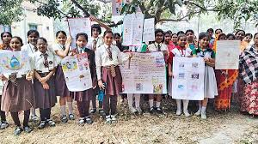
2.Education the students in the classrooms.

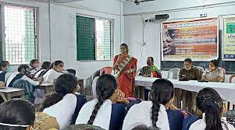

3.Using Organic Fertilizers and Compost:
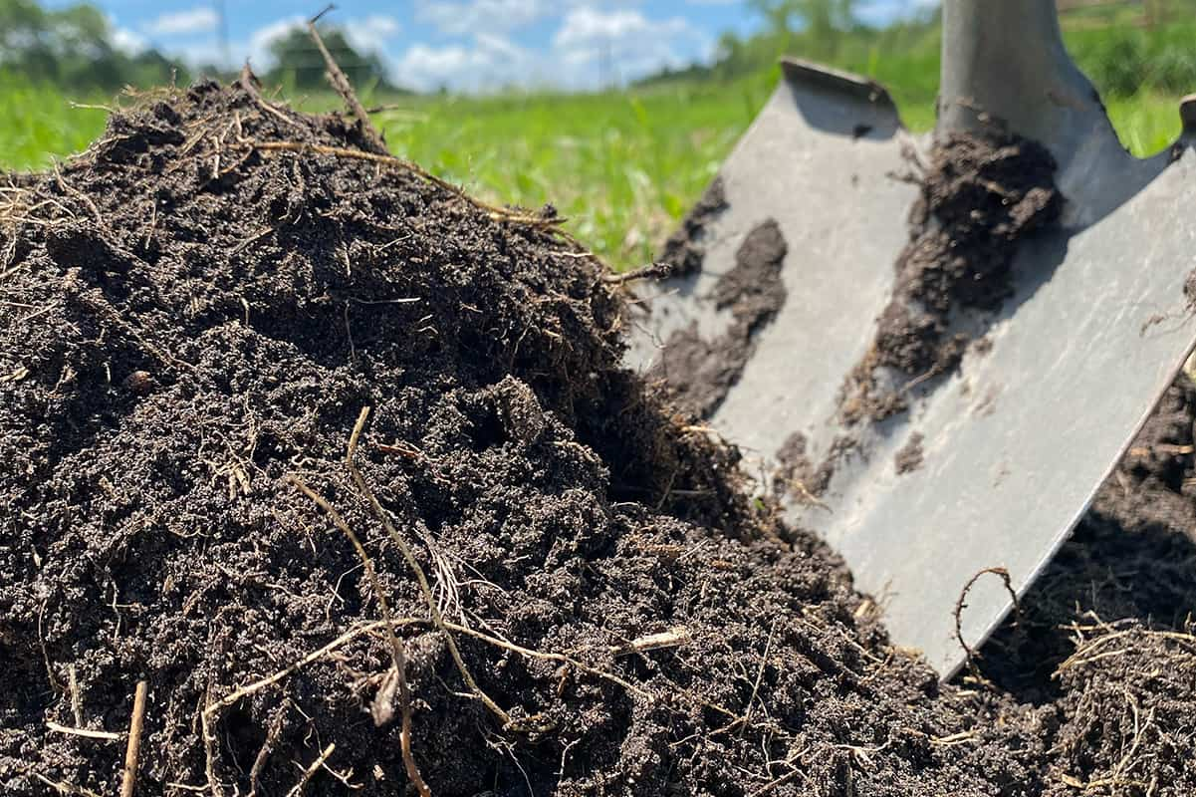

4.Mulching and Covering bare soil:

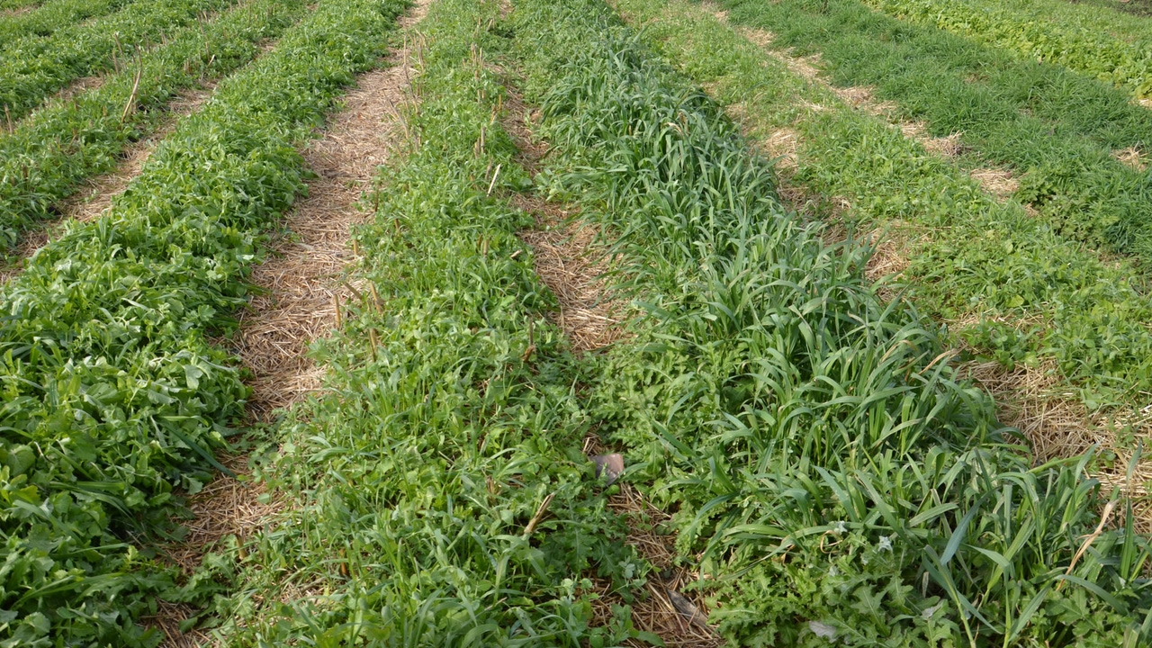

Description of the Community awareness programmes conducted with respect to the problems and their outcomes.
- Workshops on Soil Health and Conservation:
We organized interactive workshops where experts discussed the causes and impacts of soil erosion and degradation. Practical demonstrations on techniques like mulching, composting, and contour farming were conducted to illustrate effective soil conservation methods. These workshops were well-attended by farmers, youth, and community leaders eager to learn and implement sustainable practices.
- Educational Campaigns and Outreach:
Outreach activities included door-to-door campaigns, community meetings, and informational sessions held in local schools and community centers. Through these campaigns, we distributed educational materials such as pamphlets, posters, and brochures in local languages, ensuring accessibility and understanding among all demographic groups.
- Field Visits and Demonstrations:
To provide hands-on learning experiences, we organized field visits to demonstration plots where sustainable farming techniques were implemented. Participants had the opportunity to observe firsthand the benefits of practices like agroforestry, terracing, and cover cropping in preventing soil erosion and improving crop yields.
- Community Engagement and Dialogue:
We facilitated open discussions and dialogues with community members to understand their perspectives, concerns, and traditional practices related to land management. These sessions encouraged active participation and allowed community members to share their knowledge and experiences, fostering a sense of collective responsibility towards environmental stewardship.
5. Demonstration Farms and Farmer Field Schools:
To facilitate practical learning, demonstration farms and farmer field schools were established. These served as living laboratories where farmers could experiment with new techniques under guidance from agricultural experts. This hands-on approach encouraged adoption of sustainable practices through peer learning and direct experience.

Outcomes of Community Awareness Programs:
- Increased Awareness and Knowledge:
The programs significantly enhanced community awareness about the causes and consequences of soil degradation and erosion. Participants gained practical knowledge and skills in implementing sustainable agricultural practices.
- Behavioral Change:
There was observed adoption of sustainable farming techniques among participating farmers. Many started incorporating soil conservation methods into their farming practices, leading to improved soil health and reduced erosion rates in pilot areas.
- Community Empowerment:
Community members became empowered to take proactive steps in conserving natural resources. They formed local committees and groups to continue implementing and monitoring sustainable practices beyond the project's duration.
- Policy Advocacy:
The heightened awareness generated through these programs contributed to advocacy efforts for stronger environmental policies and regulations at the local level. Community leaders became advocates for sustainable land management practices, influencing local governance and decision-making processes.
- Economic Benefits:
Adoption of sustainable practices resulted in increased crop yields and reduced input costs for farmers, contributing to improved economic resilience and food security within the community.
- Environmental Resilience:
Over time, the collective efforts of the community led to enhanced environmental resilience. Reduced soil erosion not only preserved fertile land but also mitigated downstream impacts such as sedimentation in water bodies and infrastructure damage.

Report of the mini –project work done in the related subject with respect to the habitation/village.
Introduction:
Land degradation and soil erosion are critical environmental issues affecting VELVADAM. These processes are primarily driven by human activities such as deforestation, unsustainable agricultural practices, urban expansion, and industrialization. These activities disturb natural ecosystems, degrade soil quality, and compromise the ability of the land to support biodiversity and provide essential ecosystem services. In VELVADAM, these challenges are particularly significant due to [mention specific geographical or socio-economic factors affecting the area, e.g., high population density, dependence on rainfed agriculture, presence of fragile ecosystems].
The consequences of land degradation and soil erosion are far-reaching. Soil erosion, for instance, not only reduces soil fertility but also leads to increased sedimentation in water bodies, affecting water quality and aquatic habitats. Degraded lands are less productive agriculturally, impacting food security and livelihoods for local communities. Moreover, these environmental changes exacerbate climate change through carbon release from degraded soils and decreased carbon sequestration capacity. Addressing these issues requires a multi-dimensional approach that integrates scientific understanding, community engagement, and policy support to restore and sustain healthy landscapes.
In recent years, VELVADAM has experienced accelerated urbanization and agricultural expansion, leading to heightened pressure on natural resources and exacerbating land degradation. The need for sustainable land management practices has never been more urgent, as local ecosystems face unprecedented threats from human-induced activities. This mini-project seeks to provide a comprehensive assessment of the current state of land degradation and soil erosion in VELVADAM, laying the foundation for targeted interventions that promote environmental resilience and ensure the long-term sustainability of natural resources for future generations.

Objectives:
- Assess Environmental Impact:
Conduct a thorough assessment to quantify the environmental impact of land degradation and soil erosion in [Name of Community/Habitation]. This includes analyzing changes in vegetation cover, soil erosion rates, biodiversity loss, and habitat degradation to understand the overall ecological health of the area.
- Identify Socio-economic Drivers:
Identify and analyze the socio-economic drivers contributing to land degradation and soil erosion. This involves studying land use practices, agricultural intensification, urban sprawl, and socio-economic factors influencing land management decisions within the community.
- Evaluate Community Vulnerability:
Evaluate the vulnerability of local communities to the impacts of land degradation and soil erosion. Assess how these environmental changes affect livelihoods, food security, income generation, and resilience to climate-related hazards among community members.
- Recommend Sustainable Solutions:
Propose practical and sustainable solutions to mitigate and prevent further land degradation and soil erosion in [Name of Community/Habitation]. These solutions should encompass sustainable land management practices, erosion control measures, reforestation efforts, and policy recommendations aimed at promoting environmental resilience and supporting sustainable development goals.

Land Review:

Land degradation and soil erosion are pressing environmental issues that threaten the health of ecosystems worldwide. Land degradation refers to the deterioration of land quality, often caused by human activities such as deforestation, unsustainable agricultural practices, urbanization, and industrialization.
These activities strip the land of its natural vegetation cover, disturb soil structure, and decrease fertility. Soil erosion, a direct consequence of land degradation, occurs when topsoil is eroded by wind, water, or human activity, leading to the loss of nutrient-rich soil essential for plant growth. Both processes exacerbate desertification, reduce biodiversity, compromise water quality, and contribute to climate change through carbon release from degraded soils.
Addressing these challenges requires concerted efforts in sustainable land management practices, reforestation, erosion control measures, and policy interventions to mitigate and reverse the detrimental impacts of land degradation and soil erosion on ecosystems and human livelihoods alike.

Methodology:

Addressing land degradation and soil erosion requires a systematic and integrated methodology that encompasses assessment, intervention, and sustainable management practices. Initially, thorough assessments are conducted to understand the extent and underlying causes of degradation, utilizing techniques such as remote sensing, GIS mapping, and on-the-ground surveys.

Once drivers are identified—such as deforestation, unsustainable agricultural practices, or urbanization—the focus shifts to implementing sustainable land management strategies. These include practices like agroforestry, conservation tillage, and reforestation to restore vegetation cover, stabilize soil structure, and enhance biodiversity.

Concurrently, erosion control measures such as terracing, contour farming, and the use of cover crops are applied to minimize soil loss and sediment runoff. Policy frameworks play a crucial role in supporting these efforts, ensuring that regulations incentivize sustainable practices while addressing socio-economic factors.

Continuous monitoring and adaptive management are integral to this methodology, allowing for adjustments based on ongoing assessment of effectiveness and changing environmental conditions.

Results:
- The results of land degradation and soil erosion are profound and multifaceted, impacting both natural ecosystems and human communities.
- Ecologically, these processes lead to loss of biodiversity, reduced soil fertility, and increased vulnerability to desertification.
- Erosion strips away fertile topsoil, diminishing agricultural productivity and compromising water quality as sedimentation affects water bodies.
- Socioeconomically, communities dependent on agriculture suffer diminished yields and income, exacerbating poverty and food insecurity.
- Moreover, degraded lands contribute to climate change through carbon release and decreased carbon sequestration capacity.
- Addressing these challenges requires holistic approaches that integrate sustainable land management practices, policy interventions, and community engagement to restore degraded landscapes, enhance resilience, and ensure the sustainable use of natural resources for future generations.

Discussion:
- The discussion surrounding land degradation and soil erosion underscores the urgent need for comprehensive action and policy intervention at local, national, and global levels.
- These processes pose significant environmental, social, and economic challenges, threatening ecosystems, biodiversity, and livelihoods worldwide. Scientific evidence consistently highlights human activities such as deforestation, unsustainable agriculture, and urban expansion as primary drivers.
- Effective strategies must therefore prioritize sustainable land management practices, erosion control measures, and reforestation efforts to restore degraded landscapes and mitigate further degradation. Additionally, integrating land degradation and erosion considerations into broader environmental policies is crucial for addressing underlying causes and promoting resilience against climate change impacts. Community involvement and capacity building are essential for successful implementation, ensuring that local stakeholders are empowered to adopt sustainable practices and contribute to long-term environmental stewardship.
- Ultimately, fostering collaboration among governments, researchers, NGOs, and communities is key to achieving meaningful progress in combating land degradation and soil erosion, safeguarding ecosystems, and securing a sustainable future for generations to come.

Conclusion:

In conclusion, addressing land degradation and soil erosion is paramount for sustaining both ecosystems and human well-being in the face of escalating environmental challenges.

The cumulative impact of human activities has accelerated these processes, leading to profound consequences such as loss of biodiversity, reduced agricultural productivity, and increased vulnerability to climate change. Effective solutions necessitate a holistic approach that integrates scientific knowledge, policy frameworks, and community engagement.

Implementing sustainable land management practices, restoring degraded landscapes through reforestation and erosion control measures, and enforcing robust environmental policies are critical steps forward. Moreover, fostering partnerships across sectors and scaling up initiatives globally are essential to achieving lasting impacts. By prioritizing the restoration and conservation of natural resources, we can mitigate the effects of land degradation and soil erosion, ensuring resilient ecosystems and sustainable livelihoods for current and future generations.

Recommendations:

To effectively address the challenges posed by land degradation and soil erosion, several key recommendations should be prioritized.

First and foremost, there is a critical need for increased investment in research and monitoring to better understand the drivers and impacts of these processes in diverse ecological and geographical contexts.

This knowledge base should inform the development of targeted policies and regulations that promote sustainable land management practices, including agroforestry, conservation agriculture, and improved soil conservation techniques.

Community participation and education are vital, fostering local ownership of conservation efforts and ensuring that traditional knowledge is integrated into modern practices. Additionally, incentivizing, supporting landowners and farmers to adopt sustainable practices through financial mechanisms and technical support can accelerate positive change.

Collaboration among governments, NGOs, academia, and private sectors is essential for scaling up successful interventions and sharing best practices globally.

Finally, integrating land degradation and soil erosion considerations into broader environmental and development agendas, such as climate change adaptation strategies, is crucial for achieving synergistic benefits and long-term sustainability.

By implementing these recommendations collectively, we can mitigate the adverse effects of land degradation and soil erosion, promote resilience, and safeguard our natural resources for future generations.

References:

Here are some reliable references, links, and websites where you can find information on land degradation and soil erosion:

1. United Nations Environment Programme (UNEP):

Website: [UNEP - Land Degradation](https://www.unep.org/themes/land-degradation )

UNEP provides global assessments, reports, and publications on land degradation, desertification, and soil erosion.

2.Food and Agriculture Organization (FAO):

Website: [FAO - Soil Erosion](http://www.fao.org/soils-portal/soil-management/soil-erosion/en/ )

FAO offers resources, publications, and guidelines on soil erosion, soil conservation practices, and sustainable land management.

3. intergovernmental Panel on Climate Change (IPCC):

Website: [IPCC Special Reports](https://www.ipcc.ch/sr6/ )

IPCC publishes special reports that include assessments and projections related to land degradation, soil erosion, and climate change impacts on land.

CHAPTER 6: RECOMMENDATIONS AND CONCLUSIONS OFTHE MINI-PROJECT
Based on the findings of the mini-project on the lack soil degradation awareness centers, the following recommendations and conclusions can be made:

Recommendations:
Promote Sustainable Land Management: Encourage the adoption of sustainable practices such as agroforestry, conservation tillage, crop rotation, and cover cropping. These methods improve soil health, reduce erosion rates, and enhance agricultural productivity while preserving ecosystem services.
Implement Effective Erosion Control Measures: Tailor erosion control strategies to local conditions, utilizing techniques like terracing, contour farming, vegetative buffers, and check dams. These measures stabilize soil, prevent sediment runoff, and safeguard vulnerable areas from erosion.
Restore Vegetation Cover: Prioritize reforestation and afforestation efforts to restore vegetation cover, especially in degraded regions. Healthy vegetation anchors soil, mitigates erosion, and boosts biodiversity, contributing to ecosystem resilience.
Sustainably Manage Water Resources: Implement sustainable water management practices such as rainwater harvesting, soil moisture conservation, and proper drainage. These approaches minimize erosion caused by water runoff and maintain optimal soil moisture levels.
Strengthen Policy Frameworks: Develop and enforce policies that promote sustainable land use practices, regulate deforestation and land conversion, and incentivize conservation efforts across sectors. Integrated policies are crucial for addressing root causes of land degradation and erosion.

Conclusions:
Challenges and Impacts: Land degradation and soil erosion pose significant challenges to ecosystems, agriculture, and human communities worldwide. These processes diminish soil fertility, reduce agricultural productivity, and exacerbate desertification, leading to biodiversity loss and compromised water quality.
Integrated Approaches: Addressing land degradation and soil erosion requires integrated approaches that combine sustainable land management practices, erosion control measures, and policy interventions. These efforts aim to restore degraded landscapes, enhance ecosystem resilience, and promote sustainable development.
Importance of Restoration: Restoring vegetation cover through reforestation and afforestation is crucial for stabilizing soil, mitigating erosion, and preserving biodiversity. Sustainable water management practices also play a vital role in minimizing erosion and maintaining soil health.
Policy and Governance: Effective policies and governance frameworks are essential for promoting sustainable land use practices, regulating land conversion, and incentivizing conservation efforts.

Student Self-Evaluation for the Community Service Project
Student Name: RAMALA BALU
Registration No:23761A05B5
Period of CSP: From:__________ To:__________
Date of Evaluation :__________

1 | Oral communication | 1 | 2 | 3 | 4 | 5
2 | Written communication | 1 | 2 | 3 | 4 | 5
3 | Proactiveness | 1 | 2 | 3 | 4 | 5
4 | Interaction ability with community | 1 | 2 | 3 | 4 | 5
5 | Positive Attitude | 1 | 2 | 3 | 4 | 5
6 | Self-confidence | 1 | 2 | 3 | 4 | 5
7 | Ability to learn | 1 | 2 | 3 | 4 | 5
8 | Work Plan and organization | 1 | 2 | 3 | 4 | 5
9 | Professionalism | 1 | 2 | 3 | 4 | 5
10 | Creativity | 1 | 2 | 3 | 4 | 5
11 | Quality of work done | 1 | 2 | 3 | 4 | 5
12 | Time Management | 1 | 2 | 3 | 4 | 5
13 | Understanding the Community | 1 | 2 | 3 | 4 | 5
14 | Achievement of Desired Outcomes | 1 | 2 | 3 | 4 | 5
15 | OVERALL PERFORMANCE | 1 | 2 | 3 | 4 | 5
Please rate our performance in the following areas:

Rating Scale: Letter grade of CGPA calculation to be provided

Date: Signature of the Student

Student Self-Evaluation for the Community Service Project
Student Name: RAMANABOINA SOWJANYA
Registration No:22761A05B6
Period of CSP: From:__________ To:__________
Date of Evaluation :__________

1 | Oral communication | 1 | 2 | 3 | 4 | 5
2 | Written communication | 1 | 2 | 3 | 4 | 5
3 | Proactiveness | 1 | 2 | 3 | 4 | 5
4 | Interaction ability with community | 1 | 2 | 3 | 4 | 5
5 | Positive Attitude | 1 | 2 | 3 | 4 | 5
6 | Self-confidence | 1 | 2 | 3 | 4 | 5
7 | Ability to learn | 1 | 2 | 3 | 4 | 5
8 | Work Plan and organization | 1 | 2 | 3 | 4 | 5
9 | Professionalism | 1 | 2 | 3 | 4 | 5
10 | Creativity | 1 | 2 | 3 | 4 | 5
11 | Quality of work done | 1 | 2 | 3 | 4 | 5
12 | Time Management | 1 | 2 | 3 | 4 | 5
13 | Understanding the Community | 1 | 2 | 3 | 4 | 5
14 | Achievement of Desired Outcomes | 1 | 2 | 3 | 4 | 5
15 | OVERALL PERFORMANCE | 1 | 2 | 3 | 4 | 5
Please rate our performance in the following areas:

Rating Scale: Letter grade of CGPA calculation to be provided

Date: Signature of the Student

Student Self-Evaluation for the Community Service Project
Student Name: RAVI VENKATA PUSHPA LATHA
Registration No:23761A05B7
Period of CSP: From:__________ To:__________
Date of Evaluation :__________

1 | Oral communication | 1 | 2 | 3 | 4 | 5
2 | Written communication | 1 | 2 | 3 | 4 | 5
3 | Proactiveness | 1 | 2 | 3 | 4 | 5
4 | Interaction ability with community | 1 | 2 | 3 | 4 | 5
5 | Positive Attitude | 1 | 2 | 3 | 4 | 5
6 | Self-confidence | 1 | 2 | 3 | 4 | 5
7 | Ability to learn | 1 | 2 | 3 | 4 | 5
8 | Work Plan and organization | 1 | 2 | 3 | 4 | 5
9 | Professionalism | 1 | 2 | 3 | 4 | 5
10 | Creativity | 1 | 2 | 3 | 4 | 5
11 | Quality of work done | 1 | 2 | 3 | 4 | 5
12 | Time Management | 1 | 2 | 3 | 4 | 5
13 | Understanding the Community | 1 | 2 | 3 | 4 | 5
14 | Achievement of Desired Outcomes | 1 | 2 | 3 | 4 | 5
15 | OVERALL PERFORMANCE | 1 | 2 | 3 | 4 | 5
Please rate our performance in the following areas:

Rating Scale: Letter grade of CGPA calculation to be provided

Date: Signature of the Student

Student Self-Evaluation for the Community Service Project
Student Name: SAMANTHAPUDI VENKATA RAKESH VARMA
Registration No:23761A05B8
Period of CSP: From:__________ To:__________
Date of Evaluation :__________

1 | Oral communication | 1 | 2 | 3 | 4 | 5
2 | Written communication | 1 | 2 | 3 | 4 | 5
3 | Proactiveness | 1 | 2 | 3 | 4 | 5
4 | Interaction ability with community | 1 | 2 | 3 | 4 | 5
5 | Positive Attitude | 1 | 2 | 3 | 4 | 5
6 | Self-confidence | 1 | 2 | 3 | 4 | 5
7 | Ability to learn | 1 | 2 | 3 | 4 | 5
8 | Work Plan and organization | 1 | 2 | 3 | 4 | 5
9 | Professionalism | 1 | 2 | 3 | 4 | 5
10 | Creativity | 1 | 2 | 3 | 4 | 5
11 | Quality of work done | 1 | 2 | 3 | 4 | 5
12 | Time Management | 1 | 2 | 3 | 4 | 5
13 | Understanding the Community | 1 | 2 | 3 | 4 | 5
14 | Achievement of Desired Outcomes | 1 | 2 | 3 | 4 | 5
15 | OVERALL PERFORMANCE | 1 | 2 | 3 | 4 | 5
Please rate our performance in the following areas:

Rating Scale: Letter grade of CGPA calculation to be provided

Date: Signature of the Student

Student Self-Evaluation for the Community Service Project
Student Name: SAYYAD ARSHATH
Registration No:23761A05B9
Period of CSP: From:__________ To:__________
Date of Evaluation :__________

1 | Oral communication | 1 | 2 | 3 | 4 | 5
2 | Written communication | 1 | 2 | 3 | 4 | 5
3 | Proactiveness | 1 | 2 | 3 | 4 | 5
4 | Interaction ability with community | 1 | 2 | 3 | 4 | 5
5 | Positive Attitude | 1 | 2 | 3 | 4 | 5
6 | Self-confidence | 1 | 2 | 3 | 4 | 5
7 | Ability to learn | 1 | 2 | 3 | 4 | 5
8 | Work Plan and organization | 1 | 2 | 3 | 4 | 5
9 | Professionalism | 1 | 2 | 3 | 4 | 5
10 | Creativity | 1 | 2 | 3 | 4 | 5
11 | Quality of work done | 1 | 2 | 3 | 4 | 5
12 | Time Management | 1 | 2 | 3 | 4 | 5
13 | Understanding the Community | 1 | 2 | 3 | 4 | 5
14 | Achievement of Desired Outcomes | 1 | 2 | 3 | 4 | 5
15 | OVERALL PERFORMANCE | 1 | 2 | 3 | 4 | 5
Please rate our performance in the following areas:

Rating Scale: Letter grade of CGPA calculation to be provided

Date: Signature of the Student

Evaluation by the Person In-charge in the Community/Habitation
Student Registration No:
Period of CSP: From: __________ To: __________
Date of Evaluation :__________
Name of the Person In-charge:
Address with Mobile number:
Please rate the student’s performance in the following areas:

Please note that your evaluation shall be done independent of the
Student’s self-evaluation
Rating Scale: 1 is lowest and 5 is highest rank
1 | Oral communication | 1 | 2 | 3 | 4 | 5
2 | Written communication | 1 | 2 | 3 | 4 | 5
3 | Proactiveness | 1 | 2 | 3 | 4 | 5
4 | Interaction ability with community | 1 | 2 | 3 | 4 | 5
5 | Positive Attitude | 1 | 2 | 3 | 4 | 5
6 | Self-confidence | 1 | 2 | 3 | 4 | 5
7 | Ability to learn | 1 | 2 | 3 | 4 | 5
8 | Work Plan and organization | 1 | 2 | 3 | 4 | 5
9 | Professionalism | 1 | 2 | 3 | 4 | 5
10 | Creativity | 1 | 2 | 3 | 4 | 5
11 | Quality of work done | 1 | 2 | 3 | 4 | 5
12 | Time Management | 1 | 2 | 3 | 4 | 5
13 | Understanding the Community | 1 | 2 | 3 | 4 | 5
14 | Achievement of Desired Outcomes | 1 | 2 | 3 | 4 | 5
15 | OVERALL PERFORMANCE | 1 | 2 | 3 | 4 | 5

Date: Signature of the Supervisor

Photos

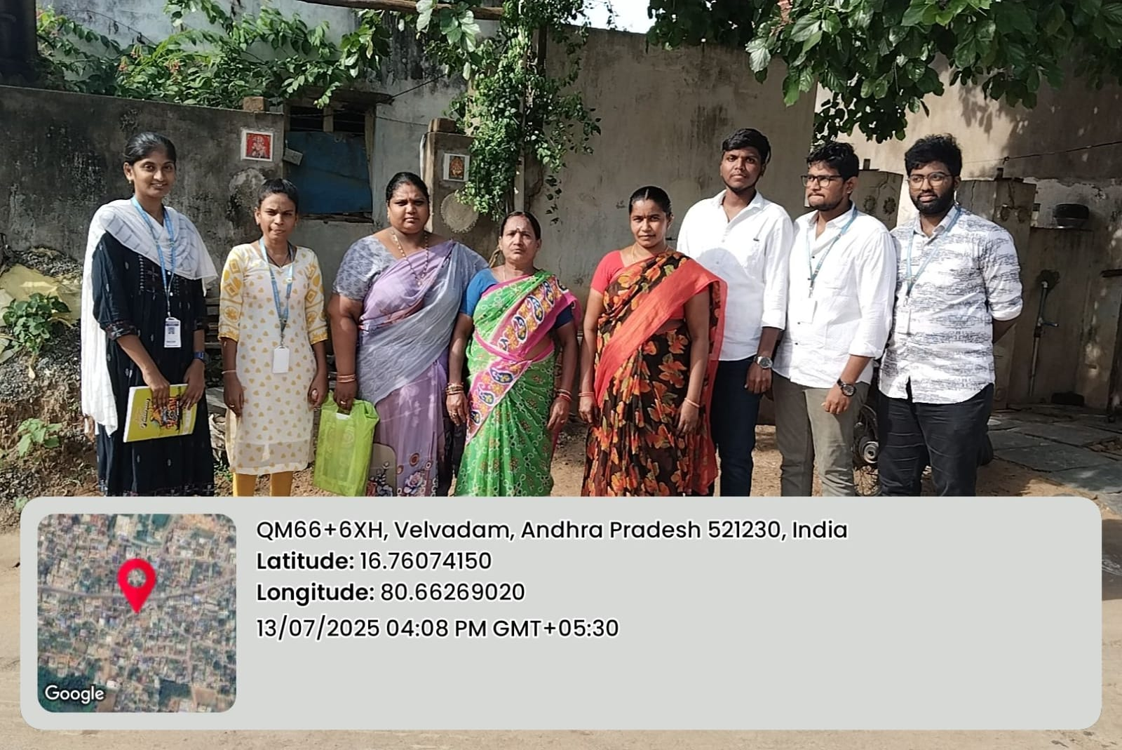

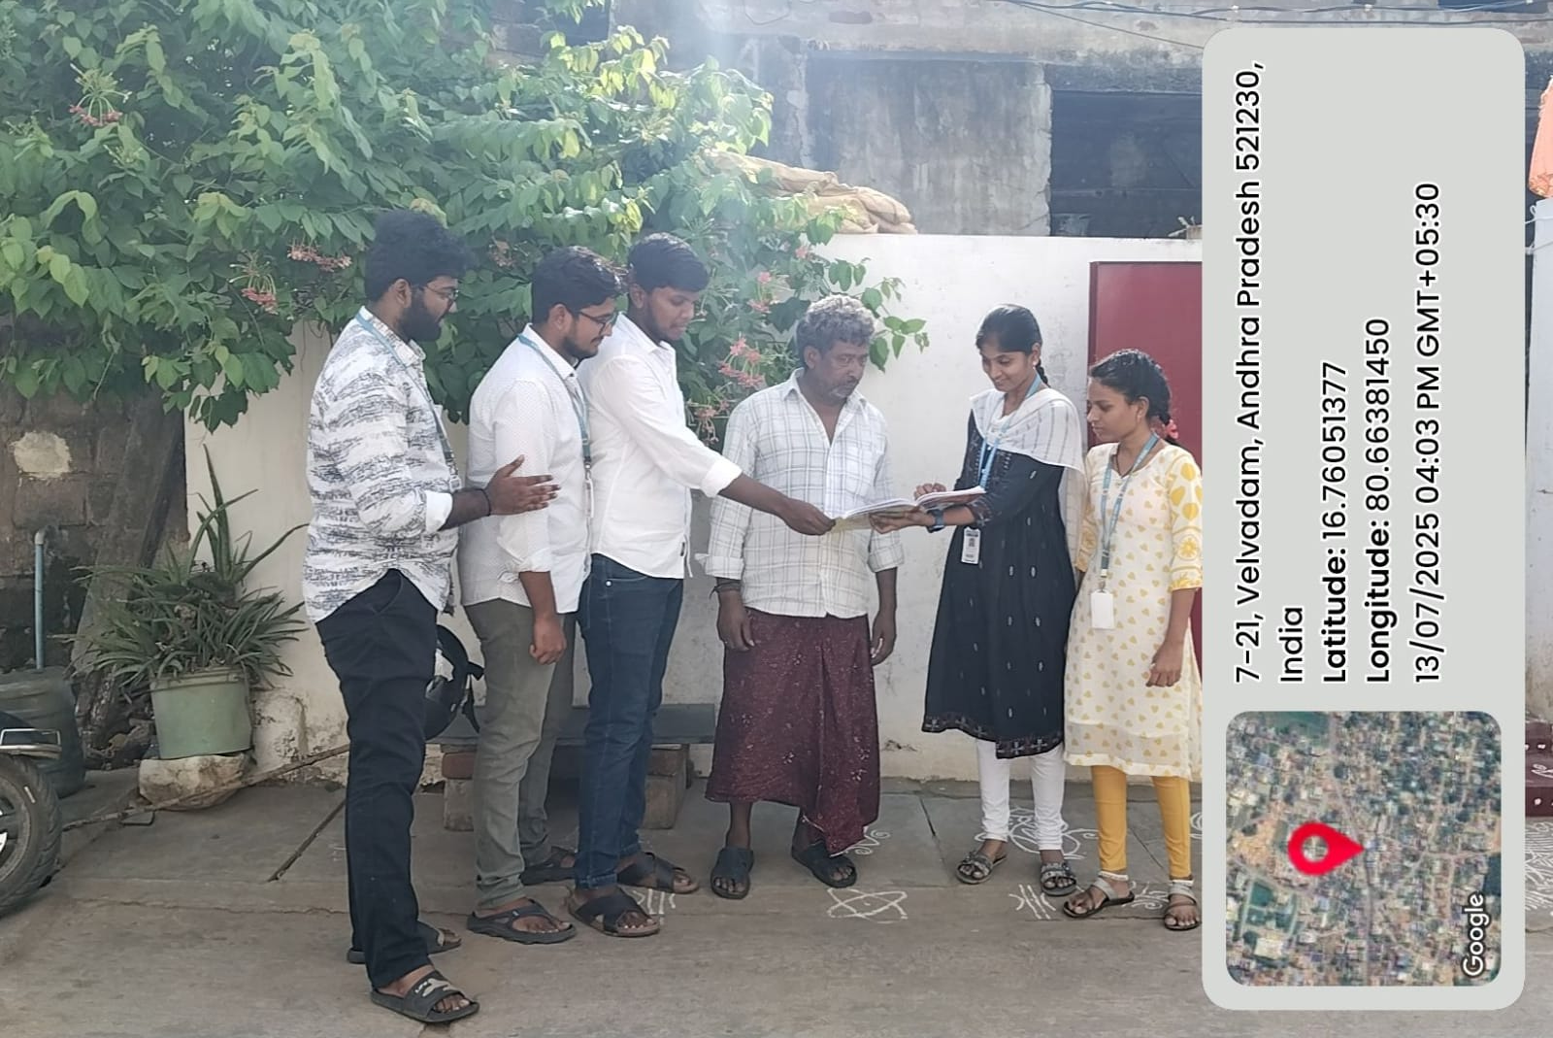

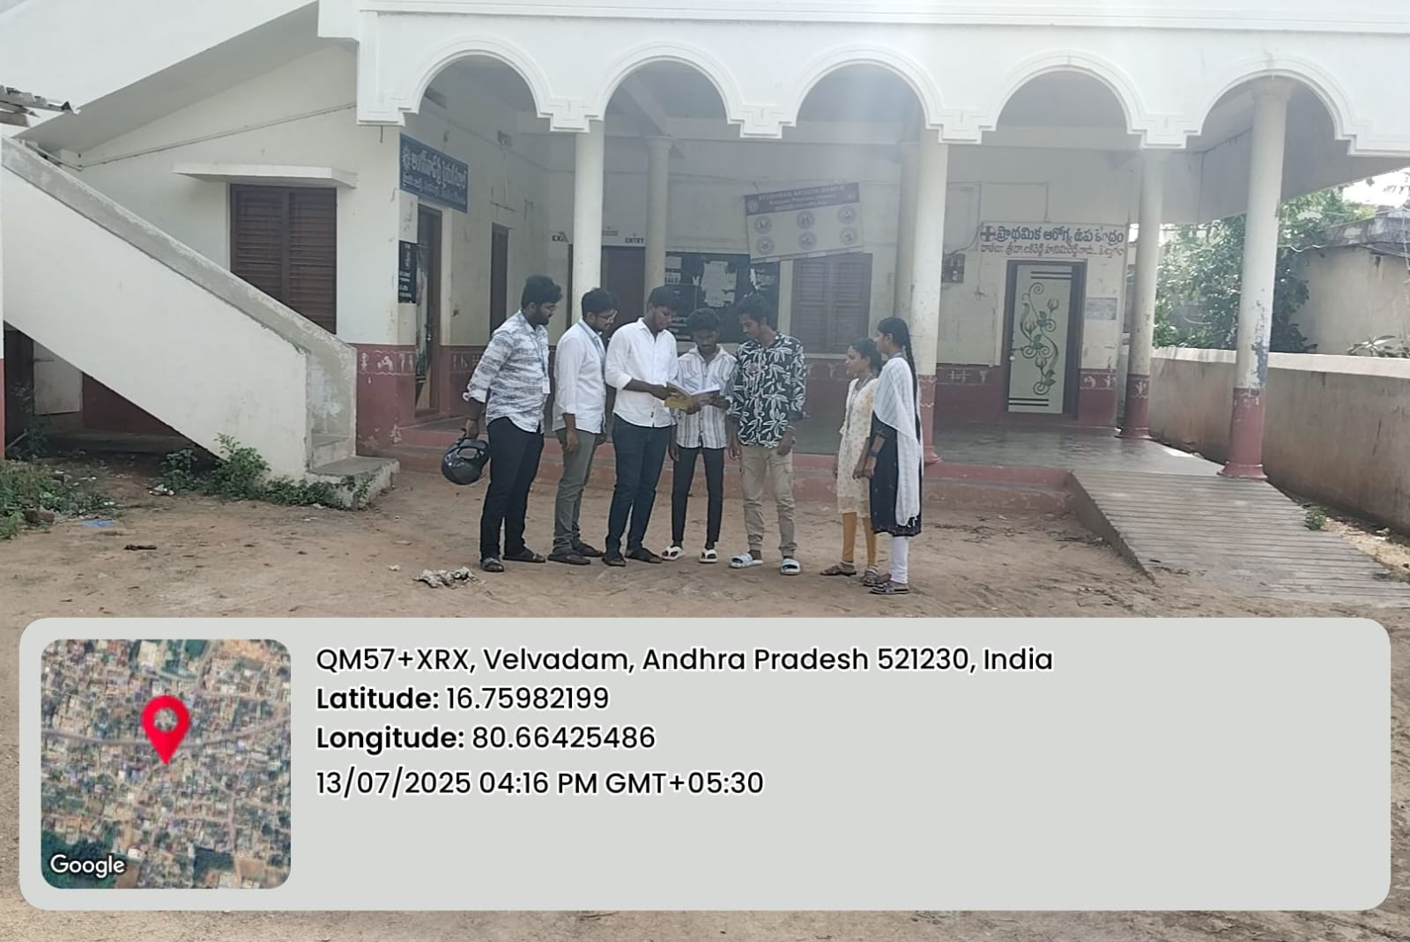

Raising awareness about the importance of soil conservation and its impact on the environment.

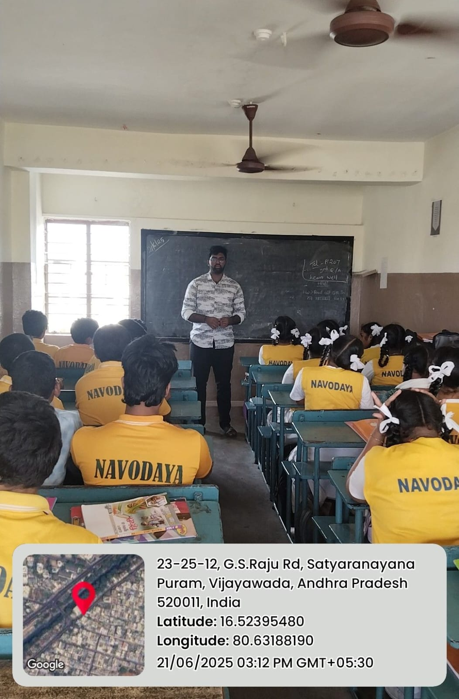

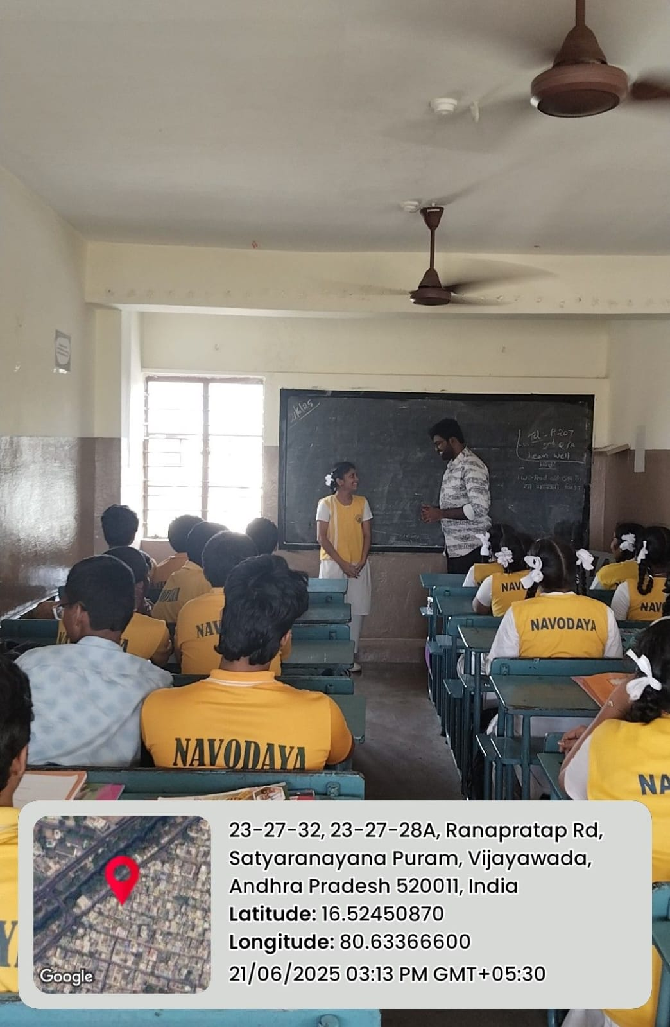

MARKS STATEMENT
(To be used by the Examiners)

INTERNAL ASSESSMENT STATEMENT

Name of the Student : RAMALA BALU
Programme of Study : B. TECH
Year of Study : 3rd YEAR
Group : CSE
Register No/H.T. No : 23761A05B5
Name of the College : LAKIREDDY BALIREDDY COLLEGE OF ENGINEERING
University : JNTUK

Sl. No | Evaluation Criterion | Maximum Marks | Marks Awarded
1. | Activity Log | 20
2. | Community Service Project Implementation | 30
3. | Mini Project Work | 25
4. | Oral Presentation | 25
 | GRAND TOTAL | 100

Date:
Signature of the Faculty Guide

Date: Certified by

Seal: Signature of the HOD /Principal

INTERNAL ASSESSMENT STATEMENT

Name of the Student : RAMANABOINA SOWJANYA
Programme of Study : B. TECH
Year of Study : 3rd YEAR
Group : CSE
Register No/H.T. No : 23761A05B6
Name of the College : LAKIREDDY BALIREDDY COLLEGE OF ENGINEERING
University : JNTUK

Sl. No | Evaluation Criterion | Maximum Marks | Marks Awarded
1. | Activity Log | 20
2. | Community Service Project Implementation | 30
3. | Mini Project Work | 25
4. | Oral Presentation | 25
 | GRAND TOTAL | 100

Date:
Signature of the Faculty Guide

Date: Certified by

Seal: Signature of the HOD /Principal

INTERNAL ASSESSMENT STATEMENT

Name of the Student : RAVI VENKATA PUSHPA LATHA
Programme of Study : B. TECH
Year of Study : 3rd YEAR
Group : CSE
Register No/H.T. No : 23761A05B7
Name of the College : LAKIREDDY BALIREDDY COLLEGE OF ENGINEERING
University : JNTUK

Sl. No | Evaluation Criterion | Maximum Marks | Marks Awarded
1. | Activity Log | 20
2. | Community Service Project Implementation | 30
3. | Mini Project Work | 25
4. | Oral Presentation | 25
 | GRAND TOTAL | 100

Date:
Signature of the Faculty Guide

Date: Certified by

Seal: Signature of the HOD/principal

INTERNAL ASSESSMENT STATEMENT

Name of the Student : SAMANTHAPUDI VENKATA RAKESH VARMA
Programme of Study : B. TECH
Year of Study : 3rd YEAR
Group : CSE
Register No/H.T. No : 23761A05B8
Name of the College : LAKIREDDY BALIREDDY COLLEGE OF ENGINEERING
University : JNTUK

Sl. No | Evaluation Criterion | Maximum Marks | Marks Awarded
1. | Activity Log | 20
2. | Community Service Project Implementation | 30
3. | Mini Project Work | 25
4. | Oral Presentation | 25
 | GRAND TOTAL | 100

Date:

Signature of the Faculty Guide

Date: Certified by

Seal:
Signature of the HOD/Principal

INTERNAL ASSESSMENT STATEMENT

Name of the Student : SAYYAD ARSHATH
Programme of Study : B. TECH
Year of Study : 3rd YEAR
Group : CSE
Register No/H.T. No : 23761A05B9
Name of the College : LAKIREDDY BALIREDDY COLLEGE OF ENGINEERING
University : JNTUK

Sl. No | Evaluation Criterion | Maximum Marks | Marks Awarded
1. | Activity Log | 20
2. | Community Service Project Implementation | 30
3. | Mini Project Work | 25
4. | Oral Presentation | 25
 | GRAND TOTAL | 100

Date:
Signature of the Faculty Guide

Date: Certified by

Seal:
Signature of the HOD/Principal

